## index

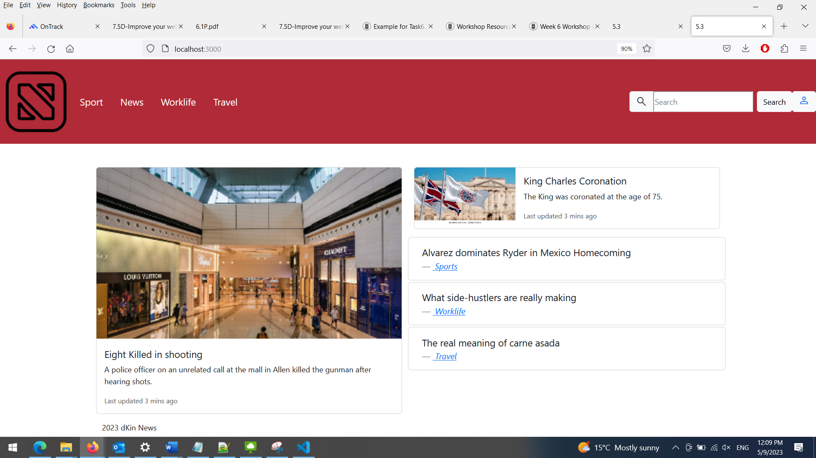

## Sport

## News

## 

## Worklife



## Travel

## Signin

